**Recommendations to boost candy sales in Canada:**

**1. Expand Customer Base**

1. Increase Advertising in Canada: The revenue from Canada is significantly lower than the US. Focus on targeted advertising campaigns to raise awareness about your candies, especially highlighting their quality and unique flavors.
2. Leverage Local Preferences: Analyze Canadian consumer preferences further to tailor products and marketing campaigns to their taste. For example, if Canadians prefer healthier options, promote sugar-free or natural ingredient candies.

**2. Optimize Product Offerings**

1. Promote Popular Flavors: Since chocolate has the highest profit ratio, focus on promoting chocolate-flavored candies in Canada. Introduce new variations or limited editions to attract attention.
2. Bundle Options: Offer promotional bundles with popular flavors, encouraging customers to try multiple options.

**3. Improve Shipping Options**

1. Expand First-Class and Same-Day Delivery: First-class delivery shows the highest usage. Consider increasing availability of fast shipping in Canada to boost customer satisfaction.
2. Reduce Standard-Class Dependence: Since second-class and standard-class deliveries are less popular, try to optimize delivery costs or introduce discounts for first-class shipping in Canada.

**4. Partnerships and Collaborations**

1. Retail Collaborations: Partner with Canadian retailers or online stores to improve candy availability in local stores.
2. Corporate Collaborations: Offer bulk discounts to Canadian companies for events and gifting.

**5. Increase Visibility**

1. Online Presence: Focus on online sales channels targeting Canadian customers. Leverage social media to engage with customers and run Canada-specific campaigns.
2. Festive Discounts: During Canadian holidays and festivals, offer discounts and themed packaging to attract buyers.

**6. Incentivize Sales**

1. Customer Rewards: Introduce loyalty programs or referral discounts for Canadian customers to encourage repeat purchases.
2. Sampling: Distribute free samples in high-traffic areas to introduce more Canadians to your candies.

**7. Data-Driven Decision Making**

1. Conduct Surveys: Gather customer feedback on what they like or dislike about your products.
2. Analyze Quarterly Trends: Use the quarterly sales forecast to predict peak demand periods and optimize inventory accordingly.

**For the US, where sales are already high, the focus should be on maintaining momentum and exploring opportunities for growth. Here are some suggestions for the US market:**

**1. Increase Market Penetration**

1. Expand State-Wise Reach: Focus on states with moderate sales and untapped potential. Strengthen distribution and marketing in those areas.
2. Local Promotions: Organize events, pop-ups, and sponsorships in states with higher customer density to solidify brand loyalty.

**2. Promote High-Profit Flavors**

1. Focus on Chocolate Flavors: Since chocolate contributes significantly to profits, expand its range with innovative flavors or packaging, such as seasonal or limited-edition themes.
2. Highlight Sugar-Free/Healthy Options: Cater to health-conscious customers by promoting sugar-free or organic variants.

**3. Leverage Shipping Insights**

1. Optimize Same-Day Delivery: The "Same Day" delivery category is performing well. Expand infrastructure to ensure consistent and faster deliveries across the US.
2. Incentivize First-Class Shipping: Encourage customers to use first-class shipping by bundling products with free or discounted shipping offers.

**4. Strengthen Customer Retention**

1. Loyalty Programs: Reward frequent buyers with discounts, exclusive products, or points redeemable for future purchases.
2. Personalized Marketing: Use customer data to offer tailored discounts or recommendations, enhancing the buying experience.

**5. Explore New Markets**

1. E-commerce Expansion: Since the US has a strong online buying culture, focus on boosting sales through platforms like Amazon, Walmart, and your website.
2. Collaborate with Corporations: Partner with US-based businesses to provide corporate gifts, bulk candy orders, or vending machine options.

**6. Drive Sales Through Innovation**

1. Sustainable Packaging: Consumers in the US are increasingly environmentally conscious. Switch to biodegradable or eco-friendly packaging.
2. Introduce Candy Subscriptions: Offer subscription boxes with new flavors and exclusive products delivered monthly.

**7. Utilize Data-Driven Forecasts**

1. Focus on High-Demand Quarters: Use your quarterly sales forecast to identify peak sales periods and launch aggressive marketing campaigns during those times.
2. Track Customer Preferences: Continue analyzing flavor preferences, state-wise performance, and sales trends to adapt quickly to changes in demand.

**These actions can help boost sales and build a stronger presence for your candy business in Canada.**

**Sales Country Wise :-**

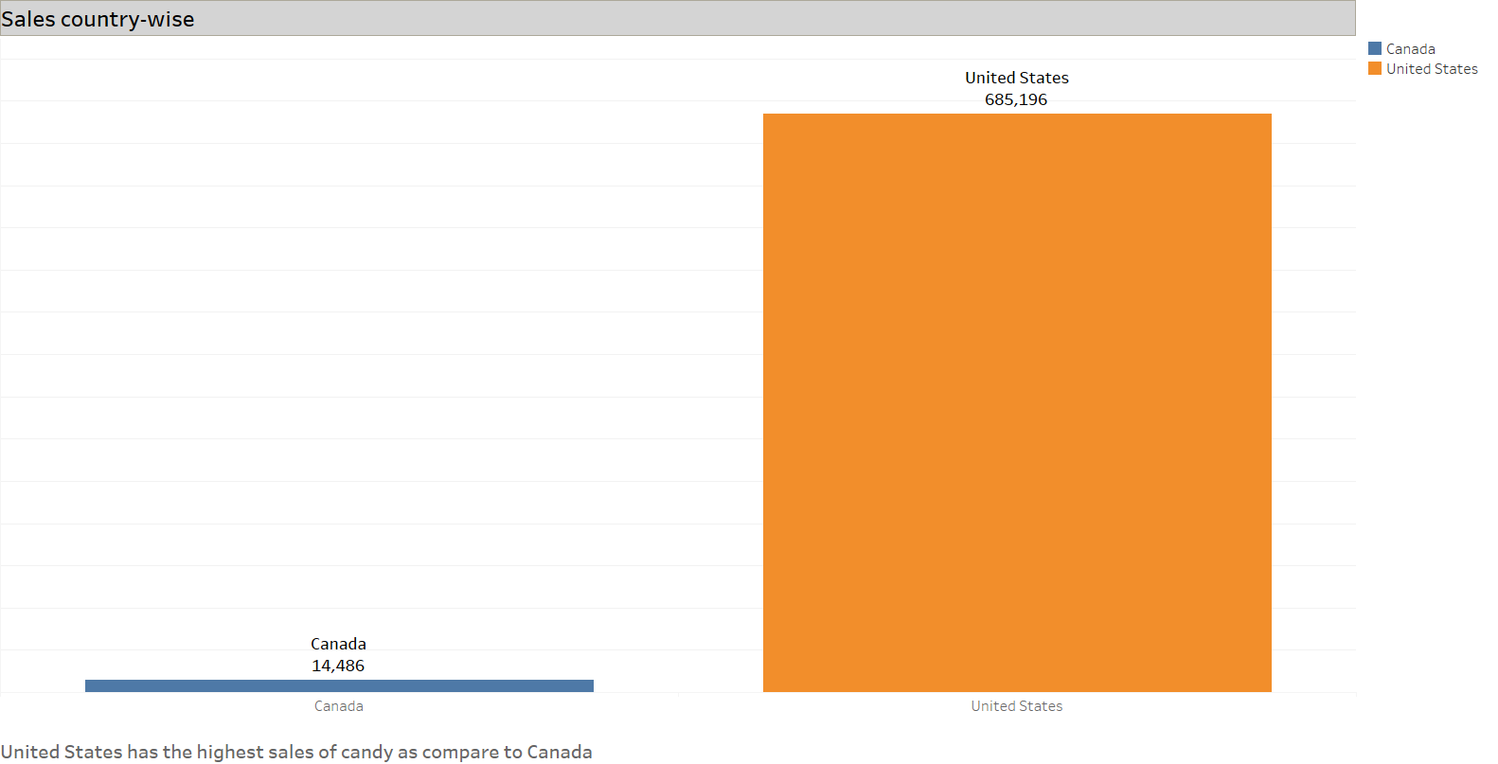

* **This bar chart is representing the total sales in Canada and United States from 2021 to 2024, United States is the leading state for the sales of candies, while Canada needs some attention towards its sales, The Insights provided above aim to improve sales performance.**

**Division wise Analysis : -**

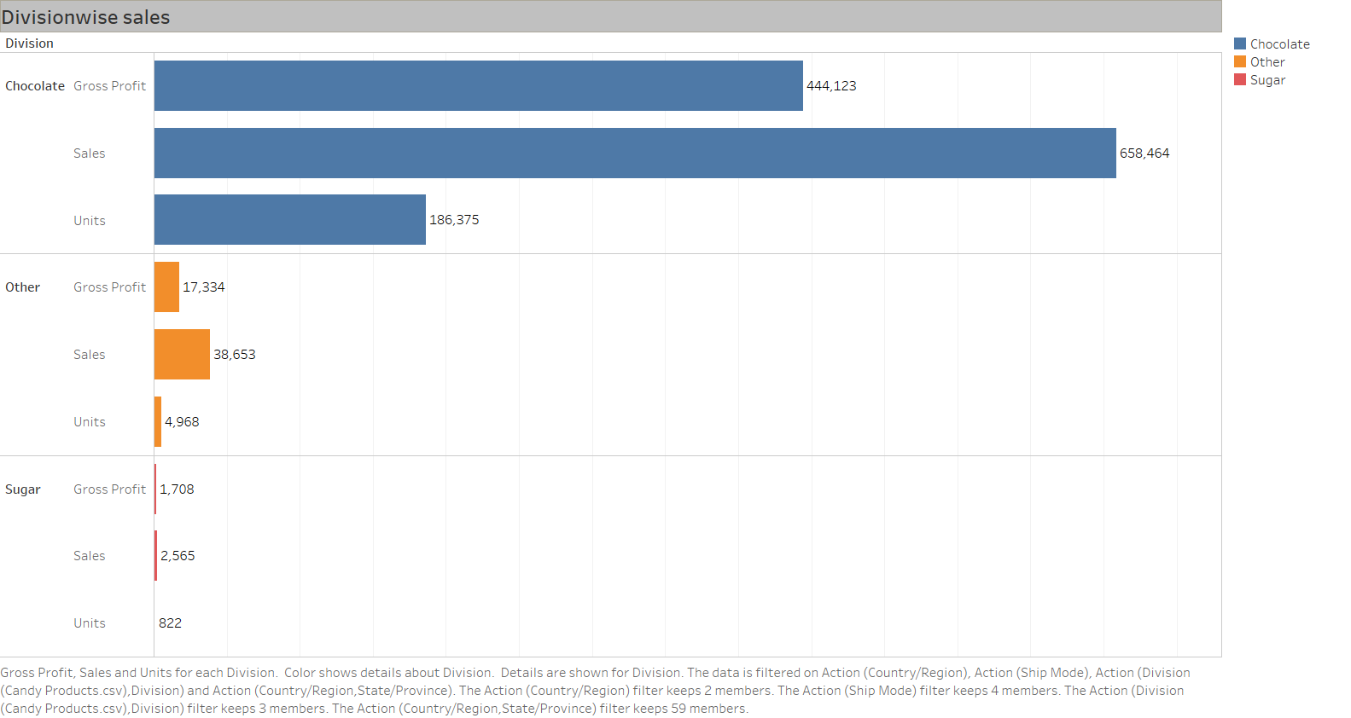

* **This bar chart represents the Division wise total sales in Canada and United States, there are 3 types of flavours in the candy in which “Chocolate” is most popular one and other 2 are “sugar” and “Other” which are the least favourite ones, so we need to increase sales in these two flavours for which the solutions I have provided above.**

“You should consider appointing "**Jimmy**" **Donaldson** as the Brand_Ambassador” A.K.A – #**Mr Beast**

